Mass Movement
Mass movement is the movement of surface material caused by gravity. Landslides and rock falls are examples of very sudden movements of this type. Geological agents such as water, wind and ice all work with gravity to cause a leveling of land.
Water aids in the downslope movement of surface material in several ways. Water adds weight to the soil; it fills pore spaces of slope material and it exerts pressure which tends to push apart individual grains. This decreases the resistance of the material to movement. Landslide is a general term that is commonly broken down into the more specialized terms such as slump, rockslide, debris slide, mudflow and earthflow.
Causes of Mass Movement
- Volcanic activity many times causes huge mudflows when the icy cover of a volcano melts and mixes with the soil to form mud as the magma in the volcano stirs preceding an eruption.
- Mudslides can also develop when water rapidly accumulates in the ground, such as during heavy rainfall or rapid snow melt, changing the earth into a flowing river of mud or "slurry."
- Earthquake shocks cause sections of mountains and hills to break off and slide down.
- Human modification (deforestation, building homes and roads that change the slope angle) of the land or weathering and erosion help loosen large chunks of earth and start them sliding downhill.
- Vibrations from machinery, traffic, weight loading from accumulation of snow; stockpiling of rock or ore; from waste piles and from buildings and other structures.
- However, the trigger mechanism for mass movement is the gravitational pull of the earth on soil, rocks, and mud.
Types of Mass Movement
LandSlides (general term)
California landslide
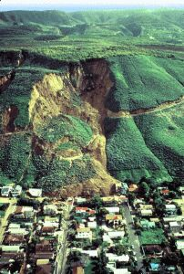 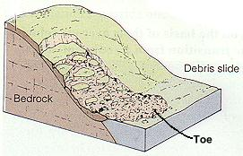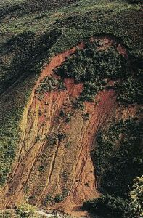
A rapid downslope movement of rock or soil as a more or less coherent mass. Landslides are characterized by a slippage plane that is clearly defined. A landslide may turn into a flow at the bottom as the blocks become tumbled over. Usually the material moves as a large block known as a slump block. The scar above a landslide is easily visible. Steep slopes of shale are susceptible to landslide activity. But landslides occur everywhere on large or small scales. They can occur after earthquakes or removal of part of the slope due to construction, particularly in the construction of roads.

Pore Water Pressure: is the key to monitoring landslides. Pore water pressure is the pressure that develops as water fills in the pore spaces in between particles. Shear strength, a resisting force, decreases and the weight, a driving force, increases.
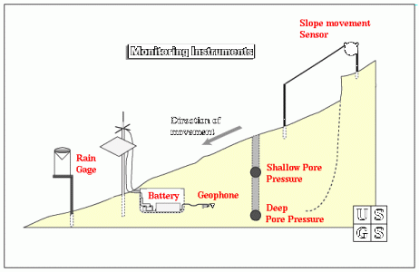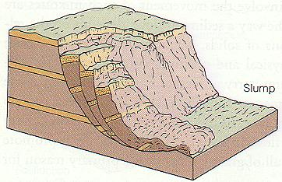
Slumps - types of slides wherein downward rotation of rock or regolith occurs along a curved surface. The upper surface of each slump block remains relatively undisturbed, as do the individual blocks. Slumps leave arcuate scars or depressions on the hill slope. Heavy rains or earthquakes usually trigger slumps.

Soil Creep
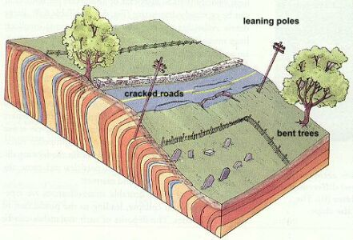
Is a very, very slow form of mass movement. It's just a slow adjustment of soil and rocks that is so hard to notice unless you can see the effects of the movement. These effects would be things like fence posts shifted out of alignment, or telephone poles tipping downslope. Another effect is the way a grass covered slope seems to ooze downhill forming little bulges in the soil. This heaving of the soil occurs in regions subjected to freeze-thaw conditions. The freeze lifts particles of soil and rocks and when there is a thaw, the particles are set back down, but not in the same place as before. Gravity always causes the rocks and soil to settle just a little farther downslope than where they started from. This is the slow movement that defines creep. Creep can also be seen in areas that experience a constant alternation of wetting and drying periods which work in the same way as the freeze/thaw.
Monitoring is essentially done through observation of the effects of creep. Since the process is so slow, it can only be monitored in terms of flow over long periods of time.

Debris Flow

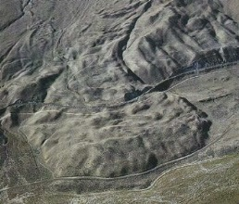
Are one of the most dangerous of all mass movement events. They can occur suddenly and inundate entire towns in a matter of minutes. Debris flows are made of exactly what the name suggests: debris. This debris can include anything from the smallest mud particles to boulders, trees, cars, and parts of buildings. Debris flows occur when rain water begins to wash material from a slope or when water sheets off of a freshly burned stretch of land. Chapparral land is especially susceptible to debris flows after a fire. The rapidly moving water cascades down the slopes, and into the canyons and valleys below. It picks up speed and some debris as it descends the valley walls. In the valley itself, months of dry ravel, loose soil and rocks that have rolled or slid off the slope, begins to move with the water. As the system gradually picks up speed, the flow takes on the characteristics of a basic river system. The faster the water flow, the more the water can pick up. As the water picks up more mud and rocks, it begins to resemble a fast flowing river of concrete. This wall of debris can move so rapidly that it can pluck boulders the size of cars from the floors of the canyons and hurl them along the path of the flow. It's the speed and enormity of carried particles that makes a debris flow so dangerous. Boulders crash through homes and the mud-water mix fills in the rooms sometime totally overtaking the house

People have tried many methods for stopping or diverting debris flows. In California, catch basins have been constructed to "catch" the debris. Some basins have special overflow ducts with screens to remove the water from the flow and allow more room for the bigger items that may be washed in and take up needed space.

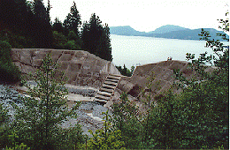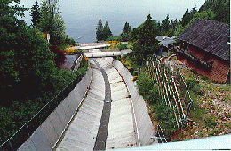
Catch basin in British Columbia, Canada Debris Chute in British Columbia, Canada

Debris flows happen so rapidly that there is really no way to monitor one until it is on top of you. Instruments in catch basins and flow channels can measure the rate or discharge of the flow by calculating the amount (volume) of material per unit of time (usually seconds)

Mudflows and Lahars
This map shows how the lahar found it's way to Armero and the extent of the flow.
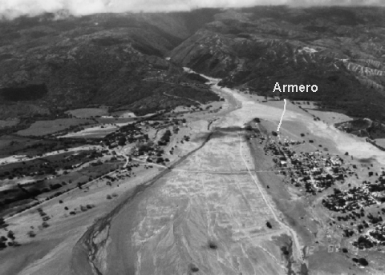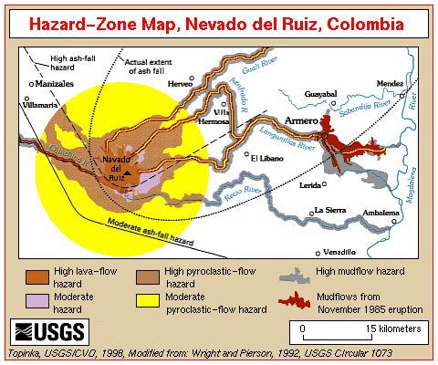
Are special forms of debris flows that are mainly made of the smallest mud and silt particles. Extremely heavy rain, or a sudden thaw can trigger these types of flows. In the case of lahars, a sudden thaw of mountain snow due to a volcanic eruption can send a torrent of mud, ash, and hot water down the slope of the volcano and over neighboring towns. As can be seen from this photograph of the unfortunate town of Armero, a lahar can overtake a town far from a volcano. This lahar rushed down stream and river valleys into the town and killed over 23,000 people. They had no warning. The town was quickly buried by mud that later, as rescuers attempted to find victims, dried and hardened like cement.

Earthflow
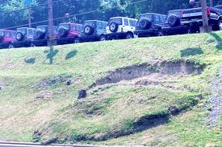
An earthflow is a downslope movement of soil which has been saturated with water to the extent that the debris moves as a fluid. While flowing, either slowly or rapidly, the mass generally remains covered by a blanket of vegetation. Typically a steep scarp is developed where the moving debris has pulled away from the upper slope. A hummocky lobe forms at the toe or front of the earthflow.

Solifluction
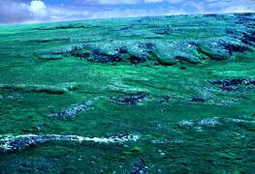
A major type of mass movement in cold polar regions and some high mountains. Solifluction is a special type of creep that occurs in areas of permafrost. Permafrost refers to the layer of groundwater that fills in the pore spaces of soil and rock that is permanently frozen. The permafrost layer can be anywhere from a meter to several hundred meters thick. It takes up about 20% of the world's land. In times of warm weather, the ground will begin to thaw from the surface downward. All of the freshly melted water cannot absorb into or move through the permafrost layer. This causes the upper layer of soil and regolith to become saturated and flow down the slightest of slopes as it slips over the frozen ground underneath.

Rock Falls and Rock Slides
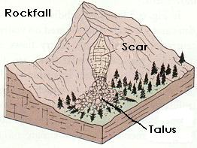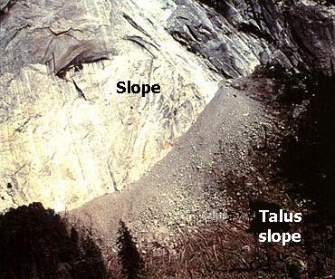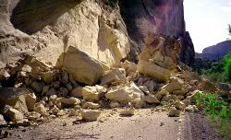
Falls are usually the free-fall of pieces of rock from a mountain or cliff face. The size of the piece(s) can range from tiny grains to blocks weighing a ton or more. The debris and rock fragments from rock falls collect at the base of the slope as talus. This talus protects the base of the mountain from erosion. On mountains, ice wedging is the main contributor. As water from snowmelt finds its way into the cracks and joints of the rock face, it may refreeze and being to expand. This expansion widens the cracks in the rock. Over time, the cracks have been widened enough so that they are a point of structural weakness. Gravity takes over and the pieces of rock fall from the face of the mountain.
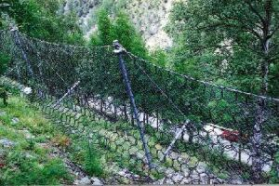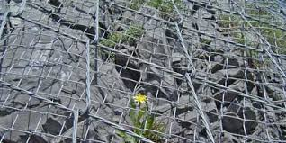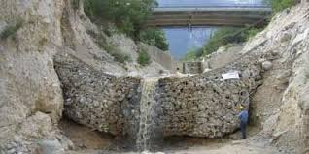
Slides are rapid downslope movements of blocks along a bedding plane, joint, or area of weakness. The blocks tend to break up into smaller pieces as the slide moves downslope and large pieces collide with each other. These pieces can travel a great distance due to the force of the falling rock. Road cuts are susceptible to rock falls and slides when the base of a mountain is removed for the roadbed. So to make the roads safer for motorists, some protective barriers have been designed to catch the falling rocks:

Prevention and Mitigation
All slopes are susceptible to mass movement hazards if a triggering event occurs. Thus, all slopes should be assessed for potential landslide hazards. Mass movements can sometimes be avoided by employing engineering techniques to make the slope more stable. Among them are:
- Steep slopes can be covered or sprayed with concrete covered or with a wire mesh to prevent rock falls (see above)
- Retaining walls could be built to stabilize a slope.
- If the slope is made of highly fractured rock, rock bolts may be emplaced to hold the slope together and prevent failure.
- Drainage pipes could be inserted into the slope to more easily allow water to get out and avoid increases in fluid pressure, the possibility of liquefaction, or increased weight due to the addition of water.
- Oversteepened slopes could be graded to reduce the slope to the natural angle of repose.
- 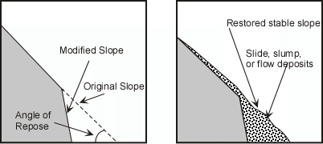
- In mountain valleys subject to mudflows, plans could be made to rapidly lower levels of water in human-made reservoirs to catch and trap the mudflows.
- Trees or other vegetation could be planted on bare slopes to help hold soil.
Some slopes, however, cannot be stabilized, or only stabilized at great expense. In these cases, humans should avoid these areas or use them for purposes that will not increase susceptibility of lives or property to mass movement hazards.

Recent Example
On Saturday, March 22, 2014, at 10:37 a.m. local time, a major mudslide occurred 4 miles (6.4 km) east of Oso, Washington, United States, when a portion of an unstable hill collapsed, sending mud and debris across the North Fork of the Stillaguamish River, engulfing a rural neighborhood, and covering an area of approximately 1 square mile (2.6 km²). As of April 30, 2014, the slide had killed 41 people; 2 more remained missing. Cause is thought to be heavy rains saturating the soil.

